Henkel
APAC Test Server
Release Notes 01-10-2025

Contents
1. CR #62562: Enhancement of Stock Verification on filling side 3
Requested Plant: Mentor 3
2. CR #70097 – Date Control Configurations for GR 5
Requested Plant: Rancho 5

Change Request #72776 Vegam - QCLAD Integration

Requested Plant: Dragon
In the current process after recording the quality results in QCLAD, the operator must separately log into the SFS system to manually update the quality outcome. This additional step introduces dependencies, increases the chance of data discrepancies, and creates delays in process execution especially in scenarios where SFS needs quality results to either complete the current process order or to proceed to the next manufacturing phase.
With this release enhancements are made in the SFS system to incorporate seamless integration with QCLAD for managing quality processes across different plants.

Plant Level Configuration
GR Sample Setting
In the Receiving Settings "Enable to receive QC results from external system” section to be enabled in the plant level.

Admin > Configure Receiving Area > Receiving Settings
When this is setting is enabled, SFS allow to receive QC results for GR samples directly from QCLAD via the integration API.
JIT Sample – QC Result Receiving
SFS introduced an enhancement in the Quality Check process for JIT samples:
- Once JIT sample labels are printed in SFS, that will be physically handed over to the QCLAD team for quality testing.
- After testing is completed, QCLAD will send the quality results back to SFS via the API endpoint. This integration ensures seamless communication of quality results and improves process efficiency.
Case 1 – Approval Scenario
When a JIT sample is generated in SFS, a physical label will be printed and handed over to the QCLAD team.
At the same time, SFS will log the sample in the Quality Module with the status “Pending” and mark it as “Awaiting test results from QCLAD”.
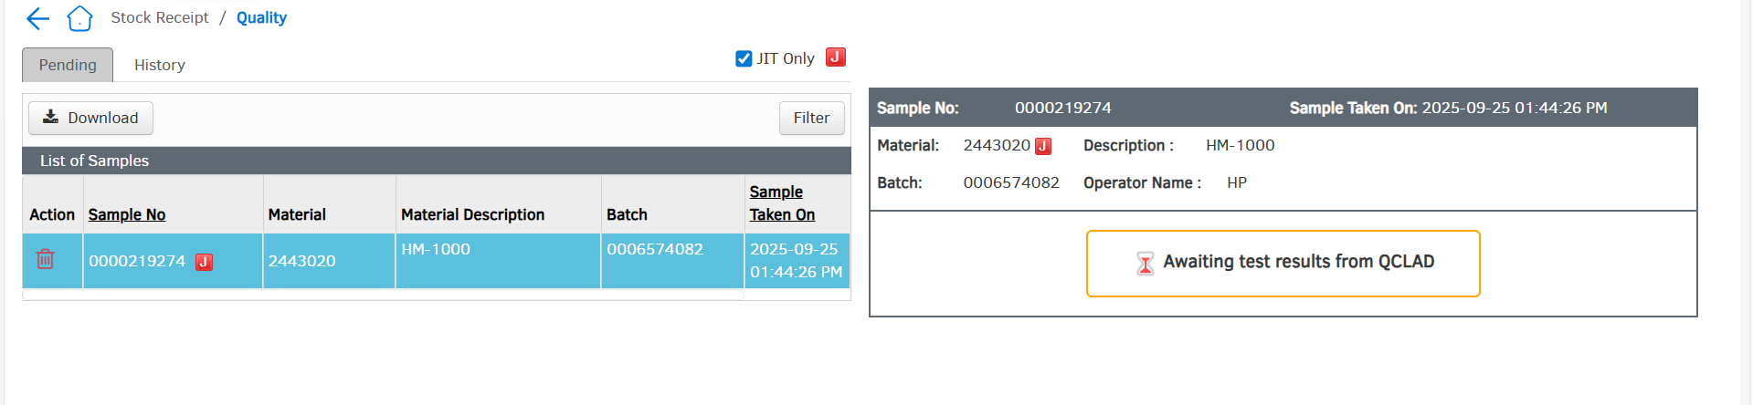
Once the QCLAD performs the required testing on the received sample. Upon successful completion and approval of the sample, QCLAD pushes the results to SFS via the designated Vegam API.
Upon receiving the “Approve” result from QCLAD, the sample record in SFS is automatically updated from “Pending” to “Pass” status. Once updated, the sample is no longer displayed in the pending list and is instead moved to the History tab for reference and archival purposes.
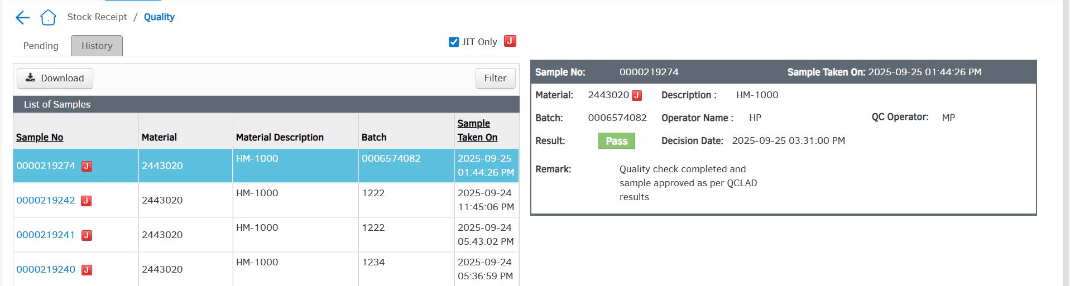
Case2: Reject Scenario
When a JIT sample is generated in SFS, a physical label will be printed and handed over to the QCLAD team.
At the same time, SFS updates the sample status to “Pending” and internally flags that QCLAD is performing the testing. QCLAD then conducts the physical quality checks and, upon completion, sends the results back through the API provided by Vegam.
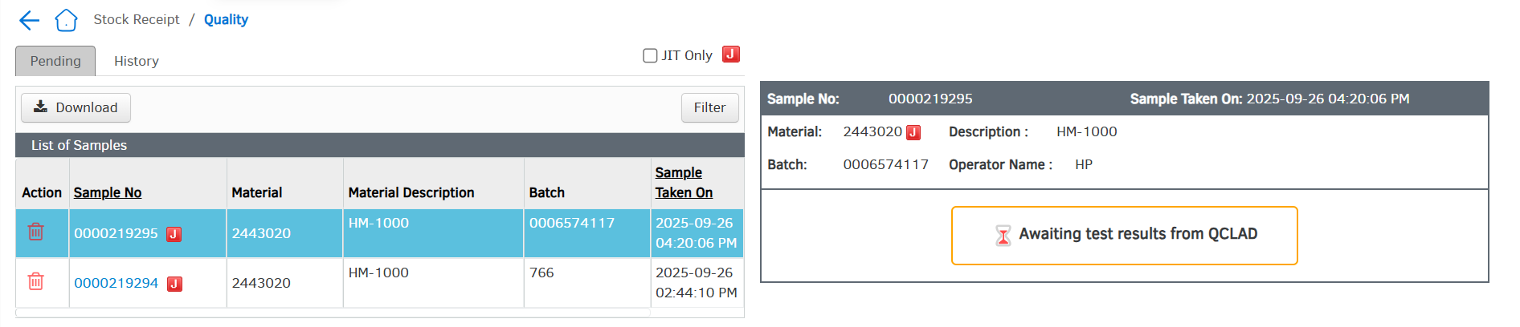
Based on these results, SFS updates the record in the quality module by marking the sample as “Rejected”, and the status is stored in the history tab along with the corresponding timestamp and result.

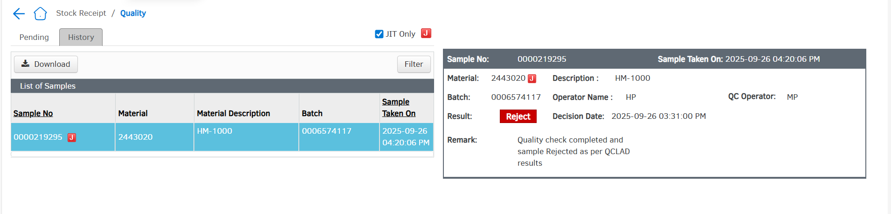
There is a permission that can be enabled called "Allow QC Pass/Reject when external QC provider is enabled." This permission is intended for supervisors, allowing them to proceed with the workflow using this special access in case of delays in QCLAD results or any QCLAD downtime. With that permission, the user can update the QC decision in SFS.
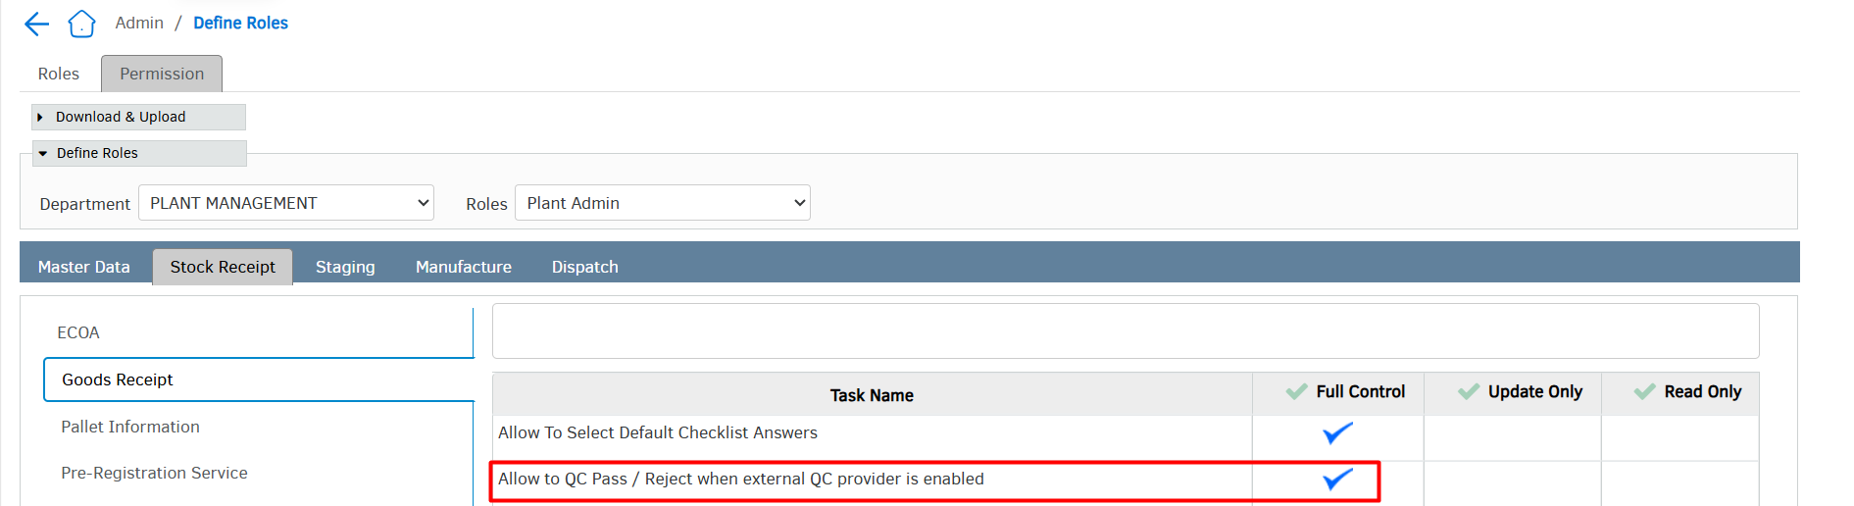
API specification Details
client_id:20361152
client_secret:4003afbf-dd06-e524-e063-0e8abb0a349e
grant_type:client_credentials

Get Access
https//sfs-ap-test.henkelgroup.net/VegamOauthServer/GetAccessToken

Sample Result
https://sfs-ap-test.henkelgroup.net/VegamOauthServer/api/data/UpdateSampleQualityInfo

